INSTITUTIONAL DEVELOPMENT PLAN (IDP)
UNDER NEP 2020
2025-2030
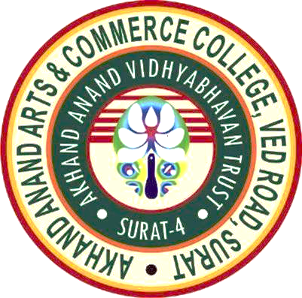

AKHAND ANAND ARTS AND COMMERCE COLLEGE
VED ROAD, SURAT-395004
DATE OF SUBMISSION :

EXECUTIVE SUMMARY
Akhand Anand Arts and Commerce College, Surat established in the year 1992 with the vision of promoting quality education and holistic development of the students, aims at creating an optimal and enriching learning environment for students to pursue their academic and sporting dreams. The College prioritizes on fostering student development, both personal and professional, in order to contribute effectively to societal needs and establish themes as an entity of the society
VISION:
- To attain excellence of students in academic programs and other activities for creating an environment that is dedicated to inculcating in students the skills and values necessary to succeed in real life situations and to make them responsible citizens. Nurturing an environment of intellectual excellence, inculcate values, identify talents and above all make good human beings.
CORE VALUES
- Quality consciousness
- Academic Excellence
- Positivity
- Honesty
- Innovation
- Service to humanity
- To attain higher consciousness

MISSION:
- The mission of the institution is to help and promote education by providing the opportunities and creating environment along with academic, cultural and social activities for holistic development of learner’s personality.

STRATEGIC GOALS:
To provide quality higher education to the students. To achieve this, along with the classroom interaction, seminars, and curricular, co-curricular and extra- curricular activities are arranged frequently.
Efforts are being made to develop humanitarian values in young minds. Importance is given on the overall development of the students through various skill development programmes.
Vision and Mission of the college focus on holistic approach to create young individual minds who can contribute to the development of the nation at larger level.

INSTITUTIONAL PROFILE

Institutional Identity:
- Name of the Institution: Akhand Anand Arts and Commerce College
- Type of Institution: Grant in Aid
- Category: Co-education
- Location: Urban
- Website Address of the College: www.akhandanandcollege.ac.in
- Name of Head of Institution and Project Nodal Officers

Head and  Nodal Officer | Name | Mobile Number | E-mail Address
Principal | Dr. Rupali A. Shah | 9825125240 | prinrupalishah@gmail.com
IDP,  Coordinator | Prof. Manisha R. Shukla | 9998037622 | khayalproduction@gmail.com

Establishment Details:

Sl. No. | Establishment Details
1 | Year of establishment | 1992
2 | Name of University to which Affiliated | Veer Narmad South Gujarat University, Surat from 1992
3 | Year of Permanent Affiliation | From 1992 onwards, Veer Narmad South Gujarat University

Affiliation: 2(f) & 12b(Annexure 1)

NAAC ACCREDITATION:
Cycle | Year of Application | Date on which accreditation was received | Grade | Valid till
1st Cycle | 2008 | 15/06/2009 | C Grade  CGPA 1.92 | 14/06/2014

PROGRAMMES OFFERED:
Sr. No. | Title of Programmes
1 | B.Com. with Accountancy
2 | B.A. with Gujarati
3 | B.A. with Economics

FACULTY AND STAFF STRENGTH

TEACHING |  | TOTAL | NON-TEACHING |  |  | TOTAL
Permanent | Ad-hoc | 16 | Permanent Clerk | Ad-hoc Clerk | Adhoc Peon Staff | 15
15 | 1 | 16 | 2 | 4 | 9 | 15

STUDENT DEMOGRAPHICS

Year | Class | GEN |  | SC |  | ST |  | SEBC |  | MINOR
Year | Class | M | F | M | F | M | F | M | F | M | F
2025-26 | B.Com Sem.-1 | 177 | 117 | 14 | 8 | 2 | 4 | 48 | 43 | 23 | 6
2025-26 | B.Com Sem.-3 | 53 | 67 | 8 | 6 | 5 | 3 | 40 | 22 | 20 | 5
2025-26 | B.Com Sem.-5 | 82 | 57 | 15 | 4 | 0 | 0 | 19 | 18 | 2 | 2
2025-26 | B.A. Sem.-1 | 59 | 29 | 7 | 6 | 1 | 1 | 26 | 8 | 4 | 0
2025-26 | B.A. Sem.-3 | 24 | 22 | 7 | 9 | 1 | 6 | 24 | 22 | 5 | 3
2025-26 | B.A. Sem.-5 | 10 | 18 | 8 | 4 | 0 | 2 | 19 | 14 | 4 | 4
TOTAL |  | 405 | 310 | 59 | 37 | 9 | 16 | 176 | 127 | 58 | 20

STRENGTH, WEAKNESS, OPPORTUNITIES AND CHALLENGES (SWOC)
INSTITUTIONAL STRENGTH
  - Only one college to receive 5 crore PM-USHA component 3 grant in surat
  - 100 KV solar system
  - Academic Excellence
  - College results higher than University results
  - Centrally located, easy accessibility
  - Adequate Infrastructure
  - State-of-the art infrastructure/facilities for teaching learning
  - Effective use of ICT infrastructure to ensure smooth academic, examination and administrative process
  - A wide range of extracurricular activities
  - Student-centered learning approach
  - Strong and supportive management
  - Numerous awareness programs on the National Education Policy (NEP) for students, Teaching and Non-teaching staff
  - Strict policies against ragging and sexual harassment, supported by Anti-Ragging, ICC and Grievance Redressal Cells
  - A well-secured campus with security guards and CCTV surveillance in whole campus
  - Recognition from government and non-government entities for the college, NSS and NCC units through awards and medals
  - Students admission in 2025-26 is 1217 both in commerce and arts programmes
  - There are 3 fellowship Ph.D. students in different subjects working in college library
  - 2400 sq. feet area of college library
  - Our college has approval of NEP honours with research
  - There is IKS corner in our college library
  - There are more than 50% Ph.D. teachers in our college
  - Our whole campus is wifi campus
  - The whole old building is renovated
  - Our B.A. Sem.-2, 4 and 6 result is more than 60%

INSTITUTIONAL WEAKNESSES
  - Lack of land for outdoor sports activities.
  - Shortage of teaching and non-teaching staff due to the affiliating system and government policies.
  - Limited space, restricting expansion opportunities.
  - Lack of flexibility in course offerings, examination conduct and evaluation due to the college is affiliated.
  - Insufficient research activities.
  - Challenges in maintaining the student-teacher ratio as an affiliated college.
  - Student-Teacher ratio
  - Dependence on Government for appointment of permanent teaching staff
  - Dependence on Government for appointment of permanent non-teaching staff
  - Our B.Com result needs improvement

INSTITUTIONAL OPPORTUNITIS
- Potential for collaboration with various agencies.
- Possibility of introducing more career-oriented courses.
- Opportunities to offer more skill-based programs.
- Admin Staff-Student Staff ratio
- Our overall result is more than university result

INSTITUTIONAL CHALLENGES
- Maintaining the student-to-computer ratio
- Generating financial resources from various sectors for overall development
- Implementing the National Education Policy (NEP) with limited resources
- Majority of the students come from lower income group and it is difficult to motivate them to join self-financed professional courses.
- Tight and cramped schedules along with co-curricular activities under semester system
- Admitting more number of students beyond UGC norms

STRATEGIC GOALS AND OBJECTIVES

SHORT TERM
- AC conference auditorium
- AC library
- AC research centre

MEDIUM TERM
- Smart class
- AC Computer lab with around 75 computers
- AC gymkhana hall

LONG TERM
- To improve students result
- Make students more active in all activities
- All the faculties to get Ph.D. degree
- Exploration of RFID & ERP

KEY FOCUS AREAS
- Academic Excellence: Value added courses Skill based courses etc.
- Research and Innovation: Seminars and conferences, Faculty development programmes
- Infrastructure Development:
Offices of cells
Solar Panels in main building and Commerce Bhavan, Separate building for Post Graduation courses Upgradation of all classrooms
- Industry Collaboration:
Association with several institutions for practical exposure of students
- Student Support and Employability:
Extension of Udisha activities
- Digital Transformation:
Exploration of RFID and ERP

ACTION PLAN
Various committees are formed for conducting several activities within a specified timeline, for which the co-ordinator of the committee and it’s members will be responsible.

MONITORING AND EVALUATION
Periodic review of all the activities shall be conducted by the Head of Institution and IQAC.

ANNEXURE
Sr. No. | TITLE
1 | 2(F) AND 12B
2 | AFFILIATION CERTIFICATE
3 | NAAC CERTIFICATE

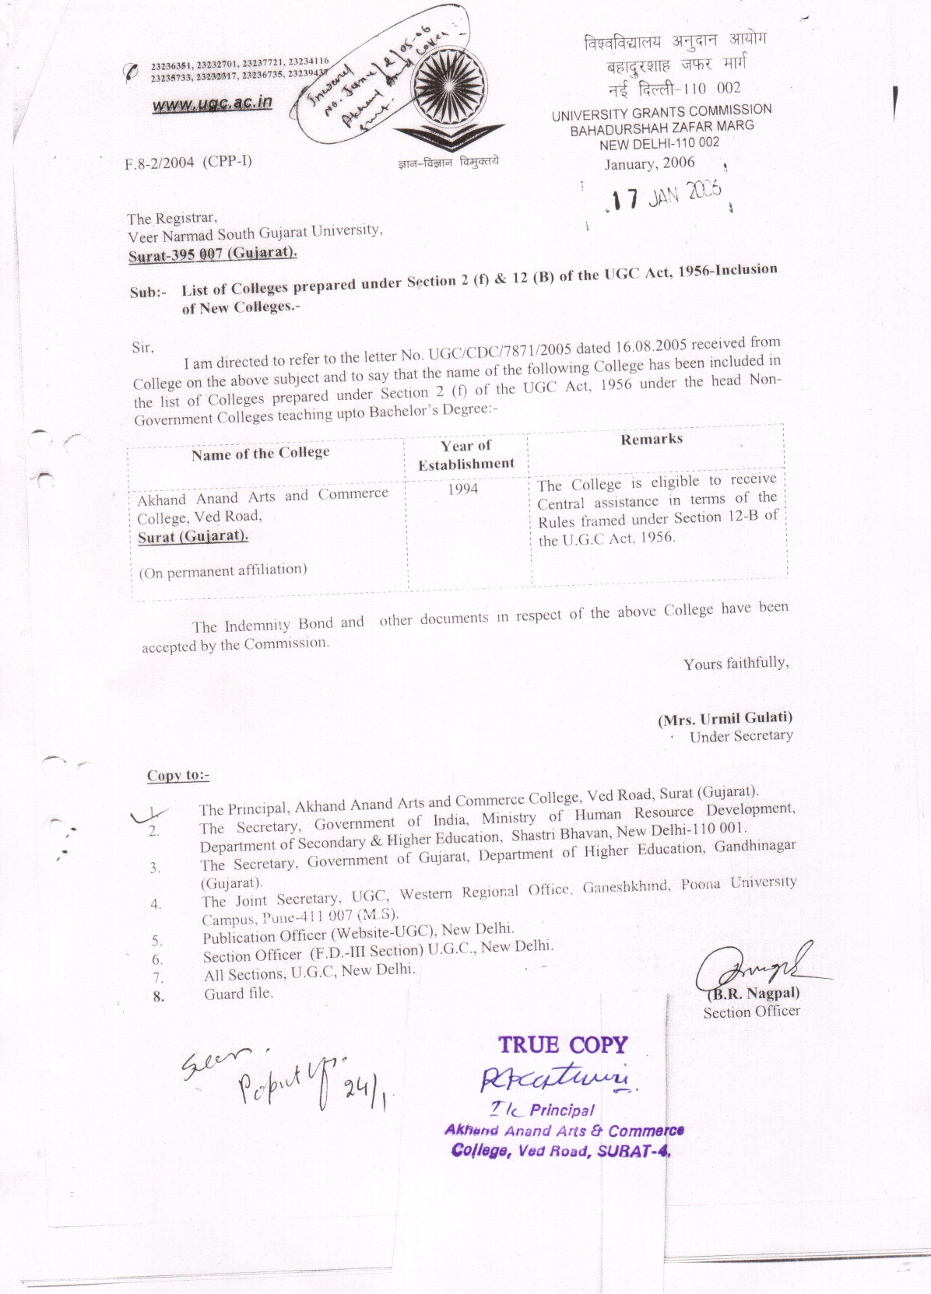
ANNEXURE-1

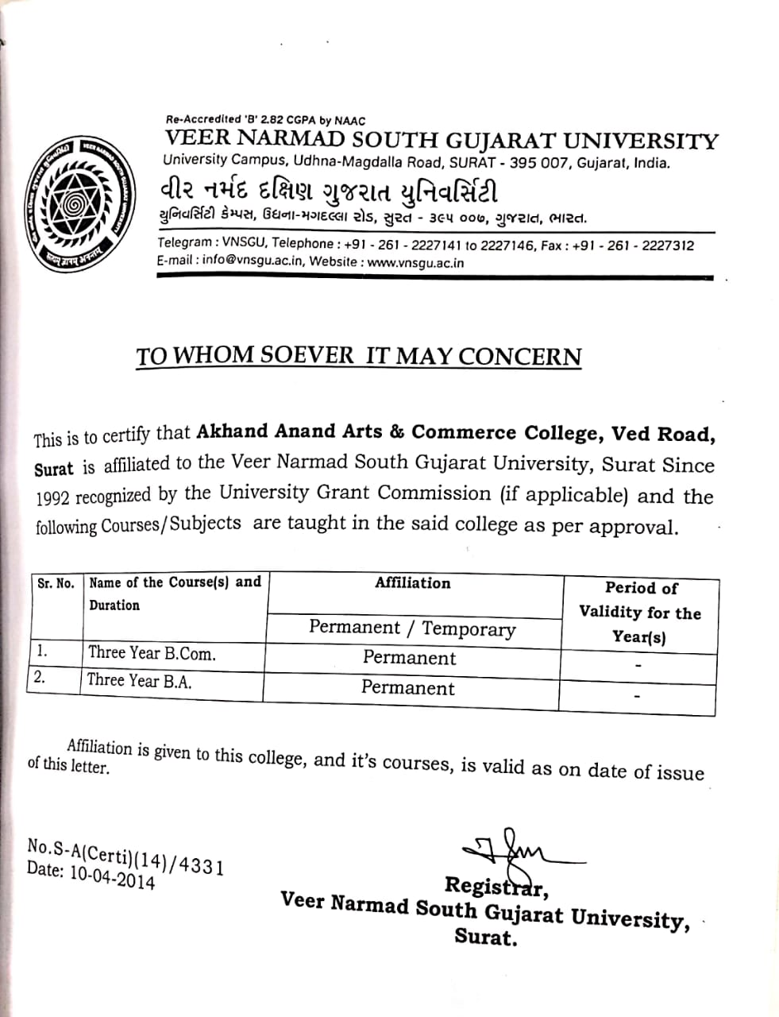
ANNEXURE-2

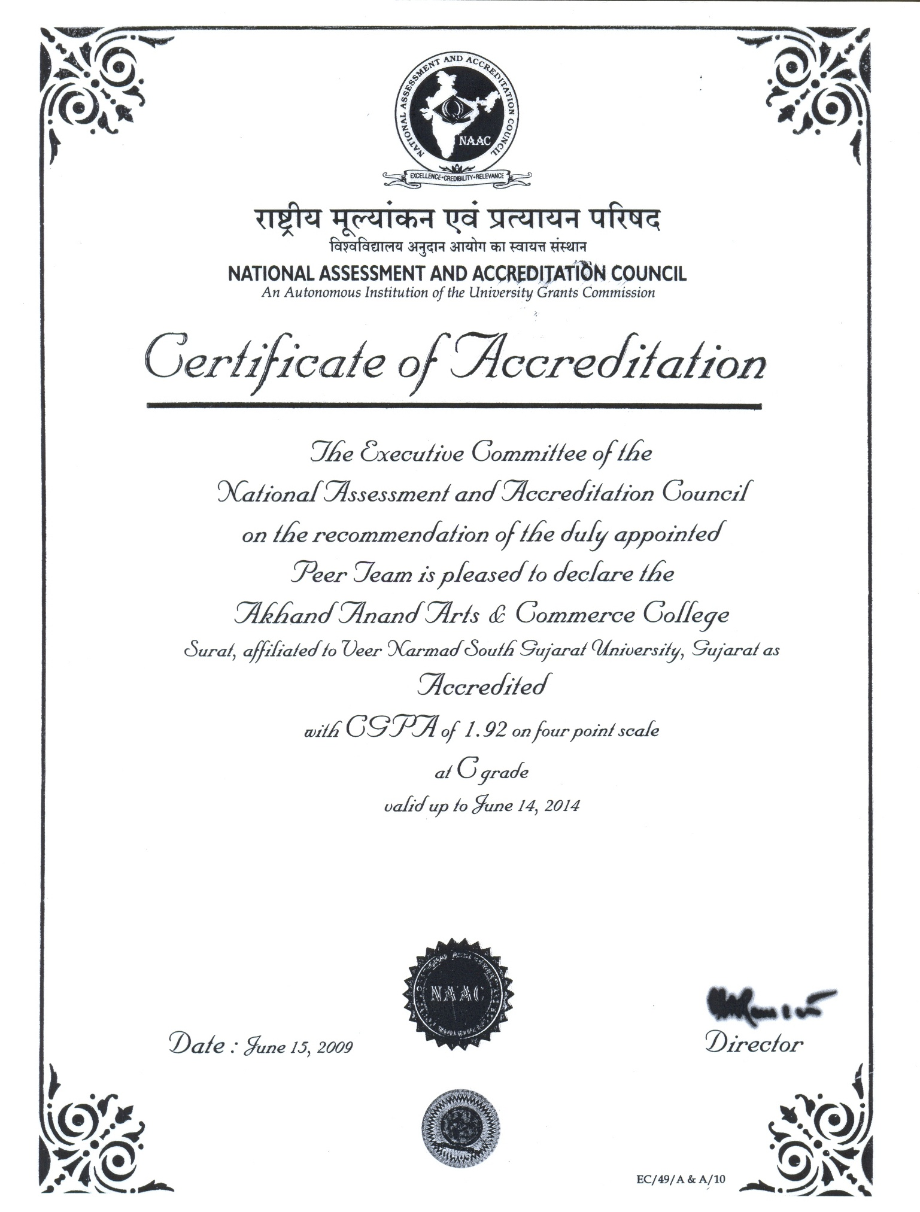
ANNEXURE-3

Management
Peon
Senior Clerk
Junior Clerk
Head Clerk
Faculties
Office Superintendent
Heads of the Department
Administrative Staff
Teaching Staff
Principal

